SIMATS ENGINEERING
ASSESSMENT TOOL 1

COURSE NAME: COMPUTER NETWORKS
COURSE CODE: CSA07

COURSE OUTCOME COVERED

CO4:
Design network topologies star, mesh, bus, and hybrid using networking devices, transmission media, and cabling standards
(BL2,BL6)

Assessment Tool Weightage: 40%

Annexure A

Coding challenge

- Develop a Python program that generates a Star Topology for a given number of hosts connected to a central switch. The program should accept the number of hosts as input and display the topology either in ASCII format or a graphical representation. For each host, print the host label, the name of the central switch, and the corresponding Cat6 UTP cable length connecting the host to the switch. Verify that all hosts are connected through the central switch and explain how the star topology facilitates reliable communication in a local area network.

- Write a Python function named validate_segment(length_m) to verify whether a given UTP cable segment satisfies the IEEE 802.3 Ethernet standard, which specifies a maximum cable length of 100 meters. The function should return True for valid cable lengths and return False along with an appropriate error message for invalid lengths exceeding the permissible limit. Demonstrate the correctness of the program by executing it with at least three different test cases and interpret the results.
- Develop a Python program to simulate the operation of the Carrier Sense Multiple Access with Collision Detection (CSMA/CD) protocol in a star topology consisting of four hosts connected through a central switch. The program should simulate frame transmission attempts, detect transmission collisions, calculate random back-off intervals, and continue transmission after the waiting period. Record every collision event, transmission attempt, and back-off interval in a log file named csma_log.txt, and analyze how CSMA/CD minimizes data transmission conflicts in Ethernet networks.

- Develop a client-server application using Python's socket library to simulate communication between two hosts connected through a central switch in a star topology. The server should receive frames from the client, forward them appropriately, and maintain a simulated MAC Address Table. After each successful frame transmission, display the updated MAC address table showing the learned MAC addresses and associated ports. Explain how MAC learning and frame forwarding are performed in Ethernet switches.

- Design and implement a Python class named StarSwitch that models the basic functionality of an Ethernet switch. The class should include methods such as add_port(host_id) to connect a host, remove_port(host_id) to disconnect a host, and broadcast(frame) to transmit a frame to all connected ports except the source port. The program should maintain a record of active ports and log every broadcast operation, indicating the source host and the destination hosts that successfully receive the frame. Demonstrate the implementation using multiple hosts and explain the significance of broadcasting in Ethernet communication.

RUBRICS FOR CALCULATION

Criteria | Weightage | Exemplary (4) | Proficient (3) | Developing (2) | Beginning (1)
Problem Understanding | 15% | Fully understands the problem and requirements; no clarification needed | Understands most requirements with minor clarification | Partial understanding; misses some requirements | Poor understanding of the problem
Algorithm Design | 20% | Efficient, optimal, and well-structured algorithm | Correct algorithm with minor inefficiencies | Basic approach but not optimal | Incorrect or no clear algorithm
Code Quality | 15% | Clean, well-organized, readable, and properly formatted code | Mostly clean code with minor issues | Code is somewhat unclear or inconsistent | Poorly written, unreadable code
Functionality | 20% | Code works perfectly for all test cases | Works for most test cases | Works for limited cases | Does not run or fails major cases
Error Handling | 10% | Handles all edge cases and errors effectively | Handles some edge cases | Limited error handling | No error handling
Efficiency | 10% | Highly optimized in time and space complexity | Reasonably efficient | Some inefficiencies | Highly inefficient
Documentation & Comments | 5% | Clear and meaningful comments and documentation | Adequate comments | Few or unclear comments | No comments
Testing & Debugging | 5% | Thoroughly tested with multiple cases; no bugs | Tested with some cases | Minimal testing | No testing done

1. Star Topology Generator
# Star Topology Generator

def create_star_topology():
try:
n = int(input("Enter number of hosts: "))

if n <= 0:
print("Number of hosts must be greater than 0.")
return

switch = "Central_Switch"

print("\n========== STAR TOPOLOGY ==========")
print(f" [{switch}]")
print(" / | \\")

for i in range(1, n + 1):
host = f"Host{i}"
length = float(input(f"Enter Cat6 cable length for {host} (meters): "))

print(f"Host: {host} --> {switch} | Cable: Cat6 UTP | Length: {length} m")

print("\nAll hosts are connected through the central switch.")
print("Star topology provides reliable communication because")
print("failure of one cable affects only the connected host.")

except ValueError:
print("Invalid input! Please enter a valid number.")

create_star_topology()

Sample Output
Enter number of hosts: 4
Enter Cat6 cable length for Host1 (meters): 20
Enter Cat6 cable length for Host2 (meters): 15
Enter Cat6 cable length for Host3 (meters): 25
Enter Cat6 cable length for Host4 (meters): 30

========== STAR TOPOLOGY ==========
Host: Host1 --> Central_Switch | Cable: Cat6 UTP | Length: 20.0 m
Host: Host2 --> Central_Switch | Cable: Cat6 UTP | Length: 15.0 m
Host: Host3 --> Central_Switch | Cable: Cat6 UTP | Length: 25.0 m
Host: Host4 --> Central_Switch | Cable: Cat6 UTP | Length: 30.0 m

All hosts are connected through the central switch.
Star topology provides reliable communication because
failure of one cable affects only the connected host.
Explanation: In a star topology, every host has a dedicated connection to the central switch. If one cable fails, other hosts can continue communicating.

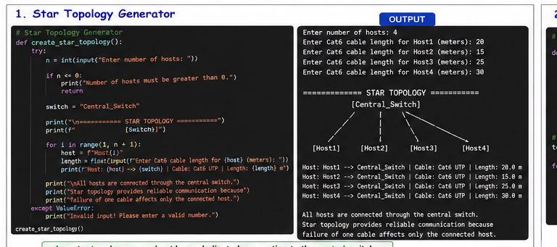

2. UTP Cable Length Validation
# UTP Cable Length Validator

def validate_segment(length_m):
MAX_LENGTH = 100

if length_m < 0:
return False, "Invalid length: Cable length cannot be negative."

if length_m <= MAX_LENGTH:
return True, "Valid: Cable length is within the 100-meter limit."

return False, "Invalid: Cable length exceeds the maximum limit of 100 meters."

# Test cases
test_cases = [50, 100, 120]

for length in test_cases:
result, message = validate_segment(length)

print(f"Length: {length} m")
print(f"Result: {result}")
print(f"Message: {message}")
print()

Output
Length: 50 m
Result: True
Message: Valid: Cable length is within the 100-meter limit.

Length: 100 m
Result: True
Message: Valid: Cable length is within the 100-meter limit.

Length: 120 m
Result: False
Message: Invalid: Cable length exceeds the maximum limit of 100 meters.

Interpretation
- 50 m → Valid
- 100 m → Valid
- 120 m → Invalid
- The program correctly rejects cable lengths greater than 100 meters.
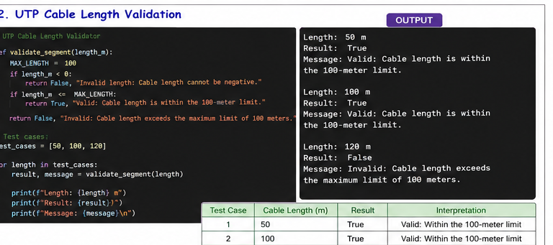

3. CSMA/CD Simulation
# CSMA/CD Simulation

import random
import time

LOG_FILE = "csma_log.txt"

hosts = ["Host1", "Host2", "Host3", "Host4"]

def log_message(message):
with open(LOG_FILE, "a") as file:
file.write(message + "\n")

def simulate_csma_cd():
# Clear previous log
open(LOG_FILE, "w").close()

print("========== CSMA/CD SIMULATION ==========")

for attempt in range(1, 6):

print(f"\nTransmission Attempt {attempt}")
log_message(f"\nTransmission Attempt {attempt}")

sender = random.choice(hosts)

print(f"{sender} wants to transmit.")
log_message(f"{sender} wants to transmit.")

# Random collision
collision = random.choice([True, False])

if collision:
print("Collision detected!")
log_message("Collision detected!")

backoff = random.randint(1, 5)

print(f"Back-off interval: {backoff} seconds")
log_message(f"Back-off interval: {backoff} seconds")

time.sleep(1)

print("Waiting period completed. Retrying transmission...")
log_message("Waiting period completed. Retrying transmission...")

else:
print("No collision. Frame transmitted successfully.")
log_message("No collision. Frame transmitted successfully.")

print(f"\nSimulation completed.")
print(f"Log saved in {LOG_FILE}")

simulate_csma_cd()

Sample Output
========== CSMA/CD SIMULATION ==========

Transmission Attempt 1
Host2 wants to transmit.
Collision detected!
Back-off interval: 3 seconds
Waiting period completed. Retrying transmission...

Transmission Attempt 2
Host4 wants to transmit.
No collision. Frame transmitted successfully.

Transmission Attempt 3
Host1 wants to transmit.
Collision detected!
Back-off interval: 2 seconds
Waiting period completed. Retrying transmission...

Simulation completed.
Log saved in csma_log.txt

csma_log.txt
Transmission Attempt 1
Host2 wants to transmit.
Collision detected!
Back-off interval: 3 seconds
Waiting period completed. Retrying transmission...

Transmission Attempt 2
Host4 wants to transmit.
No collision. Frame transmitted successfully.

Explanation
CSMA/CD works by:
- Host senses the communication medium.
- Host starts transmission when the medium is free.
- Collision is detected if two hosts transmit simultaneously.
- A random back-off interval is selected.
- The host waits and retransmits.
Note: Modern switched full-duplex Ethernet generally does not use CSMA/CD, but this simulation demonstrates the protocol concept requested in the assignment.
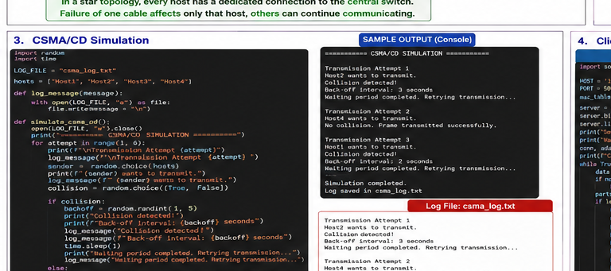

4. Client-Server Application with MAC Address Table

Server Program
Save as server.py
import socket

HOST = "127.0.0.1"
PORT = 5000

mac_table = {}

server = socket.socket(socket.AF_INET, socket.SOCK_STREAM)
server.bind((HOST, PORT))
server.listen(5)

print("Server started...")
print("Waiting for client connection...")

conn, address = server.accept()

print(f"Connected to client: {address}")

while True:
data = conn.recv(1024).decode()

if not data:
break

# Expected format:
# MAC,PORT,MESSAGE
parts = data.split(",", 2)

if len(parts) == 3:
mac, port, message = parts

# Learn MAC address
mac_table[mac] = port

print("\nFrame received")
print(f"Source MAC : {mac}")
print(f"Port : {port}")
print(f"Message : {message}")

print("\nUpdated MAC Address Table")
print("-------------------------")

for mac_address, switch_port in mac_table.items():
print(f"{mac_address} -> {switch_port}")

conn.send("Frame received and MAC address learned.".encode())

conn.close()
server.close()

Client Program
Save as client.py
import socket

HOST = "127.0.0.1"
PORT = 5000

client = socket.socket(socket.AF_INET, socket.SOCK_STREAM)
client.connect((HOST, PORT))

print("Connected to server.")

mac = input("Enter Source MAC Address: ")
port = input("Enter Switch Port: ")
message = input("Enter message/frame data: ")

data = f"{mac},{port},{message}"

client.send(data.encode())

response = client.recv(1024).decode()

print("\nServer Response:")
print(response)

client.close()

Sample Output — Server
Server started...
Waiting for client connection...
Connected to client: ('127.0.0.1', 52341)

Frame received
Source MAC : AA:BB:CC:DD:EE:01
Port : Port1
Message : Hello Host2

Updated MAC Address Table
-------------------------
AA:BB:CC:DD:EE:01 -> Port1

Explanation
An Ethernet switch uses MAC learning to remember which MAC address is connected to which port.
For example:
MAC Address Port
---------------------------
AA:BB:CC:DD:EE:01 Port1
AA:BB:CC:DD:EE:02 Port2
AA:BB:CC:DD:EE:03 Port3
When a frame arrives, the switch:
- Learns the source MAC address.
- Stores the MAC address and incoming port.
- Checks the destination MAC address.
- Forwards the frame to the appropriate port.
- If the destination is unknown, it can flood the frame to other ports.

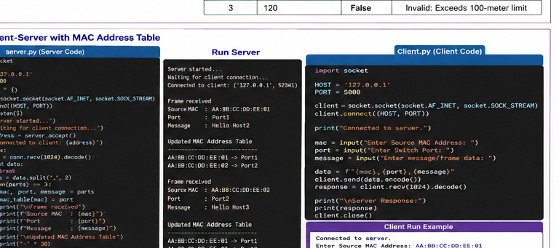

5. StarSwitch Class
# StarSwitch Class

class StarSwitch:

def __init__(self):
self.active_ports = []
self.log_file = "broadcast_log.txt"

def add_port(self, host_id):
if host_id not in self.active_ports:
self.active_ports.append(host_id)
print(f"{host_id} connected to the switch.")
else:
print(f"{host_id} is already connected.")

def remove_port(self, host_id):
if host_id in self.active_ports:
self.active_ports.remove(host_id)
print(f"{host_id} disconnected from the switch.")
else:
print(f"{host_id} is not connected.")

def broadcast(self, frame, source):
if source not in self.active_ports:
print(f"{source} is not connected to the switch.")
return

receivers = [
host for host in self.active_ports
if host != source
]

print(f"\nBroadcast from {source}")
print(f"Frame: {frame}")

for host in receivers:
print(f"Frame received by {host}")

# Log operation
with open(self.log_file, "a") as file:
file.write(
f"Source: {source} | "
f"Frame: {frame} | "
f"Destinations: {receivers}\n"
)

# Demonstration

switch = StarSwitch()

switch.add_port("Host1")
switch.add_port("Host2")
switch.add_port("Host3")
switch.add_port("Host4")

print("\nActive Ports:")
print(switch.active_ports)

switch.broadcast("Hello Network", "Host1")

switch.broadcast("Data Packet", "Host3")

switch.remove_port("Host4")

print("\nActive Ports after removing Host4:")
print(switch.active_ports)

switch.broadcast("New Frame", "Host2")

Sample Output
Host1 connected to the switch.
Host2 connected to the switch.
Host3 connected to the switch.
Host4 connected to the switch.

Active Ports:
['Host1', 'Host2', 'Host3', 'Host4']

Broadcast from Host1
Frame: Hello Network
Frame received by Host2
Frame received by Host3
Frame received by Host4

Broadcast from Host3
Frame: Data Packet
Frame received by Host1
Frame received by Host2
Frame received by Host4

Host4 disconnected from the switch.

Active Ports after removing Host4:
['Host1', 'Host2', 'Host3']

Broadcast from Host2
Frame: New Frame
Frame received by Host1
Frame received by Host3

